# Chapter 3: DEVELOPMENT METHODOLOGY

## 3.1 Description of the methodology

**Object oriented analysis methodology** will be chose for this project. It will used for better performance, smooth running and fine finishing of the project. Object-oriented analysis and design (OOAD) is a technical approach used in the analysis and design of an application or system through the application of the object-oriented paradigm and concepts including visual modeling (techopedia.com, 2019).

Waterfall model fits for this project. Waterfall methodology is the first introduced model. It is very simple and easy to understand. In waterfall model, each phase must be complete before the next phase. It is very suitable for this project or any other project because the outcome of one phase act as the input for the next phase sequentially. It is easy to arrange task, well-understood milestones and its process and result are well document. (tutorialspoint.com, 2019)

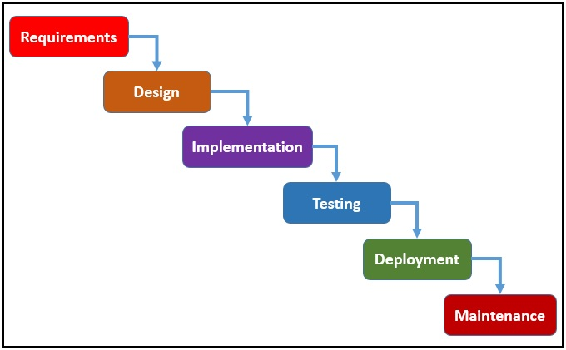

Figure-waterfall model

## 3.2 Design Pattern

MVC design pattern will used in this project. MVC stand for model-view-controller, this pattern used to separate application concerns. Where model represent an object. It can also have logic to update controller if its data changes. View represent the visualization of the data that model contain and controller act as both view and model. (tutorialspoint.com, 2019)

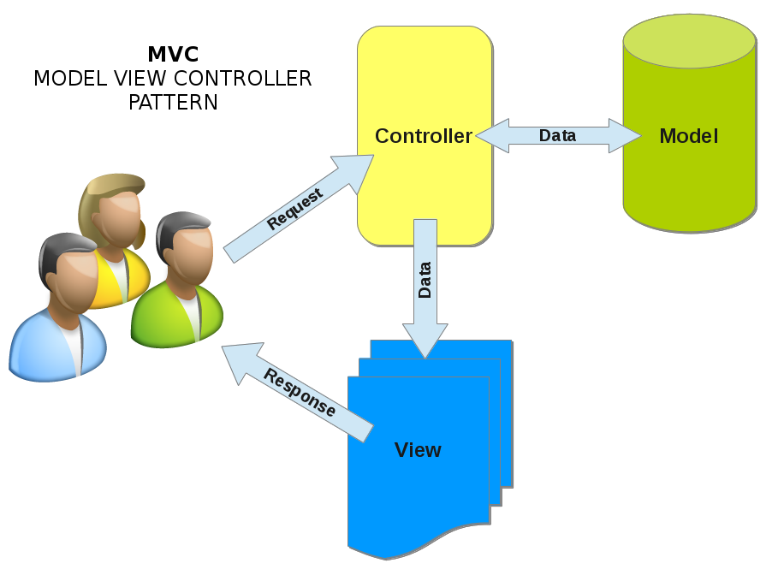

Figure- MVC Pattern

## 3.3 Architecture

Three-tier architecture is a client server architecture in functional process logic, data access, computer data storage and user interface are developed and maintained as independent modules on separated platforms. Consists of three pattern and they are presentation, application and data tier (techopedia.com, 2019).

**Presentation tier:**

This tier, which built using HTML5, CSS and JavaScript, is organised to computing device through a web browser and web-based system.

**Application tier:**

This also called as middle tier, logic tier; it is pull from the presentation tier and control the application functionality by performing detailed processing.

**Data tier:**

It is the database server where information where store and retrieve. Data in this tier is kept independent of application server.

(techopedia.com, 2019)

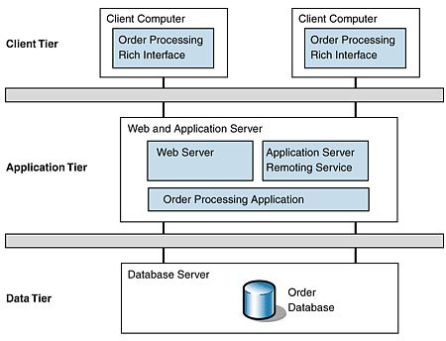

Figure: Three tier architecture